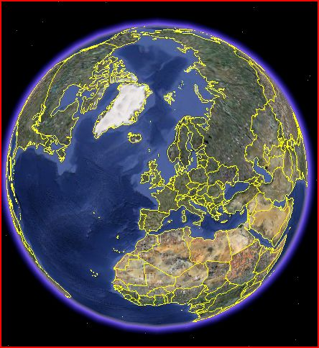
Google Earth – Street View

Method of having Street View pictures of your home removed

- Open Google Earth
- In “Layers” make sure Street View is ticked
- Zoom in to your property (with scroll wheel on mouse)
- Select the camera graphic nearest to your house
- Single click it (double clicking opens it)
- Select “Report Inappropriate Image” which opens your browser
- Select “Privacy Concerns” and a menu will drop down
- Click on “My House” and a short menu drops down
- Select “I have found a picture of my house and would like it removed “
- Fill in a description of the problem
- Fill in your email address – you will be informed of removal progress
- Type in the Word Verification (CAPTCHA) letters
- Finally click Submit

Your picture should be removed by Google in the next few days, both from Google Earth and Google Maps, and be replaced by a totally black frame.

